Assignment-1

Answers

8 1 2022

## Q1 : How many characters do have at least one starship? List the names of the characters having at least one starship.

* There are 20 characters who have at least one starship.

|  |  |  |
| --- | --- | --- |
| name | ships | strchpcount |
| Obi-Wan Kenobi | Jedi starfighter, Trade Federation cruiser, Naboo star skiff, Jedi Interceptor, Belbullab-22 starfighter | 5 |
| Anakin Skywalker | Trade Federation cruiser, Jedi Interceptor, Naboo fighter | 3 |
| Padmé Amidala | H-type Nubian yacht, Naboo star skiff, Naboo fighter | 3 |
| Luke Skywalker | X-wing, Imperial shuttle | 2 |
| Chewbacca | Millennium Falcon, Imperial shuttle | 2 |
| Han Solo | Millennium Falcon, Imperial shuttle | 2 |
| Darth Vader | TIE Advanced x1 | 1 |
| Biggs Darklighter | X-wing | 1 |
| Wedge Antilles | X-wing | 1 |
| Jek Tono Porkins | X-wing | 1 |
| Boba Fett | Slave 1 | 1 |
| Lando Calrissian | Millennium Falcon | 1 |
| Arvel Crynyd | A-wing | 1 |
| Nien Nunb | Millennium Falcon | 1 |
| Ric Olié | Naboo Royal Starship | 1 |
| Darth Maul | Scimitar | 1 |
| Plo Koon | Jedi starfighter | 1 |
| Gregar Typho | Naboo fighter | 1 |
| Grievous | Belbullab-22 starfighter | 1 |
| Poe Dameron | T-70 X-wing fighter | 1 |

## Q2 : Get the frequencies of the eye colors of the characters. Rank them from most to least.

|  |  |
| --- | --- |
| eye_color | count |
| brown | 21 |
| blue | 19 |
| yellow | 11 |
| black | 10 |
| orange | 8 |
| red | 5 |
| hazel | 3 |
| unknown | 3 |
| blue-gray | 1 |
| dark | 1 |
| gold | 1 |
| green, yellow | 1 |
| pink | 1 |
| red, blue | 1 |
| white | 1 |

## Q3. According to the data available, what are the average age values across each species? Find the 3 oldest species.

|  |  |  |
| --- | --- | --- |
| species | Count | Avg_age |
| Yoda’s species | 1 | 896 |
| Hutt | 1 | 600 |
| Wookiee | 2 | 200 |

## Q4. Create a new data set by adding a new observation to this data.

|  |  |  |  |  |  |  |  |  |  |  |  |  |  |
| --- | --- | --- | --- | --- | --- | --- | --- | --- | --- | --- | --- | --- | --- |
| name | height | mass | hair_color | skin_color | eye_color | birth_year | sex | gender | homeworld | species | films | vehicles | starships |
| Sithbuster | 180 | 90 | brown | white | brown | 119 | male | masculine | Naboo | Human | The Phantom Menace, Return of the Jedi |  | Cutthroat |

## Q5. Calculate the body mass index (BMI) values (dividing the mass value in kg to the square of the height value in meter) for all observations and categorize the observations as underweight (BMI below 18.5), healthy (BMI between 18.5-24.99), overweight (BMI between 25.0-29.99) and obese (BMI above 30.0). Add these two variables to your new data created at the 4th question.

|  |  |  |  |  |  |  |  |  |  |  |  |  |  |  |  |
| --- | --- | --- | --- | --- | --- | --- | --- | --- | --- | --- | --- | --- | --- | --- | --- |
| name | height | mass | hair_color | skin_color | eye_color | birth_year | sex | gender | homeworld | species | films | vehicles | starships | BMI | BMI_gr |
| Luke Skywalker | 172 | 77 | blond | fair | blue | 19 | male | masculine | Tatooine | Human | The Empire Strikes Back, Revenge of the Sith , Return of the Jedi , A New Hope , The Force Awakens | Snowspeeder , Imperial Speeder Bike | X-wing , Imperial shuttle | 26.02758 | Overweight |
| C-3PO | 167 | 75 | NA | gold | yellow | 112 | none | masculine | Tatooine | Droid | The Empire Strikes Back, Attack of the Clones , The Phantom Menace , Revenge of the Sith , Return of the Jedi , A New Hope |  |  | 26.89232 | Overweight |

…

## Q6. Plot the distribution of ages less than 100 by BMI groups. (i.e. use filter function to select the ages less then 100)

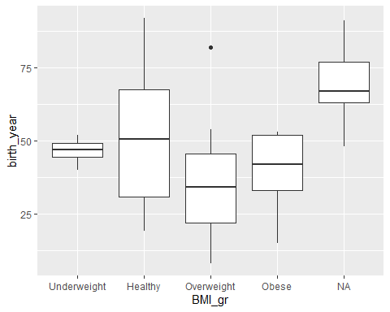

Figure 1. The distribution of ages less than 100 by BMI groups

## Q7. By plotting a graph, show the relationship between age and BMI values (use point and line at the same time).

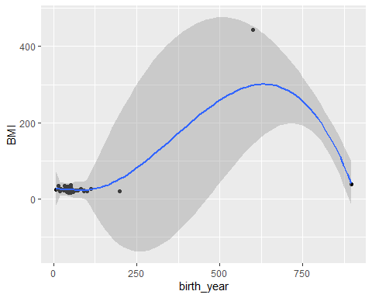

Figure 2. The relationship between age and BMI values

## Q7. Re-plot the same graph after filtering the data as both age and BMI less than 100.

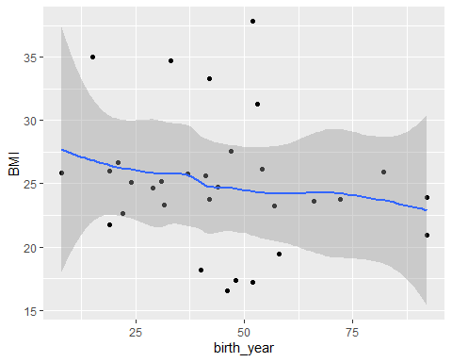

Figure 3. The relationship between age (<100) and BMI (<100) values